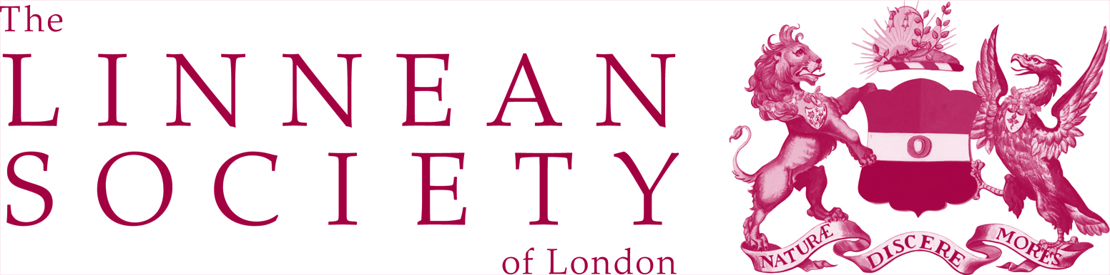
Proposal form for a Day Meeting at the Linnean Society of London
- Day Meetings are conferences / symposia / events / meetings that are pertinent to the Society’s aims, are organised in partnership with the Linnean Society and are hosted at the Linnean Society, Burlington House, London.
- Day Meetings usually last one or two days and we support approximately four Day Meetings per year.
- Day Meeting organisers are provided with the Meeting Room and Library to host the meeting and will work in collaboration with Linnean Society staff in running the event. Day Meeting organisers can apply for additional funds for speaker travel and accommodation and for refreshments for delegates
- Applications may be submitted at any time of year, but ideally should be received at least 1 year before the date of the proposed meeting.
- Funding is provided in advance of a meeting to allow organisation to proceed smoothly.
- Successful applicants will be expected to provide a 500 word summary of the meeting to be published on the Linnean Society website.

Title of Meeting:

Major themes & objectives

Name and contact details of principal organisers:

Proposed date and duration (number of days)of the meeting:

Who will this event appeal to and what is the approximate number of attendees expected Please note, that the Linnean Society has a maximum capacity of 100

Provisional speakers (as far as is known):
Please note, proposers should aim to organise meetings with a diverse representation of speakers.

Will the meeting be organised jointly with another society or organisation? If so, please name it and say how it will be involved

How much/what kind of support is requested from the Linnean Society?

How will this support be used?

Why is the meeting timely and deserving of this support?

How will this event be publicised and what will be the registration arrangements?

Do you have any plans for publication following this event?

Please return this form to:
The Linnean Society of London, Burlington House, Piccadilly, London, W1J 0BF or events@linnean.org

The proposal will be evaluated at the next programmes committee meeting which take place in February, June and November.

