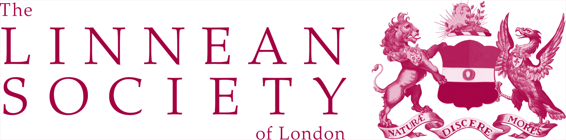
Proposal form for a Lunchtime Lecture at the Linnean Society of London

- Linnean Lunchtime Lectures take place once a month in the Meeting Room at the Linnean Society and last 30 minutes.
- Linnean Lunchtime Lectures are free and open to all.
- They should be rooted in natural history and accessible to the general public attracting a broad audience to the society.
Proposed speaker:

Major themes & objectives

Name and contact details of principal proposer:

Have you seen this speaker before? If so, please give details of the talk you attended and your experience at the talk.

Why is the meeting timely and relevant to the Society’s programme?
Please return this form to: The Linnean Society of London, Burlington House, Piccadilly, London, W1J 0BF or events@linnean.org
The proposal will be evaluated at the next programmes committee meeting which take place in February, June and November.

